COVID-19 and Palliative and End of Life
in Secondary Care
Guidance to aid care
Version 6: 17 January 2021

Please check on the APM website (https://apmonline.org) to ensure
that you are reading the most up-to-date version of this guidance

This guidance is aimed at all professionals supporting patients with COVID-19, and their families, in the hospital setting.

Guidance for use in the community setting has been produced by the Royal College of General Practitioners and is available at:
https://elearning.rcgp.org.uk/pluginfile.php/149457/mod_page/content/22/COVID%20Community%20symptom%20control%20and%20end%20of%20life%20care%20for%20General%20Practice%20FINAL%20v2.docx.pdf.

Guidance for those caring for paediatric patients has been produced by the Association for Paediatric Palliative Medicine and is available at: https://www.england.nhs.uk/coronavirus/wp-content/uploads/sites/52/2020/04/C0249_Clinical-guidelines-for-children-and-young-people-with-palliative-care-needs_17-April-.pdf

Collated for the Association for Palliative Medicine of Great Britain and Ireland by:
Dr Iain Lawrie and Dr Sarah Cox

Please note

The COVID-19 outbreak currently being experienced around the world is unprecedented and requires everyone to work together to contribute to the health and well-being of populations as well as ensure that appropriate guidance and sharing of good practice occurs. This is essential in order to support the care of patients at the end of their lives or who are significantly unwell as the result of either COVID-19 or other possibly life-limiting illnesses.

This guidance, initially prepared and collated locally by the Northern Care Alliance NHS Group (NCA) and the Association for Palliative Medicine of Great Britain and Ireland (APM), is not intended to be comprehensive. The APM acknowledges the contribution made by staff within the NCA to the first version of the guidance and colleagues nationally who have inputted into all versions via the APM.

While this work has informed national guidance, it is not endorsed by NHSE, but may be useful to colleagues when preparing their own guidance. Please feel free to use, adapt and share this guidance appropriately, acknowledging where specific individuals have been identified as contributing to discrete parts of the guidance.

This will be a ‘live’ document that will be adapted as further updates become available. The most recent version of the guidance will be available on the public-facing pages of the APM website (https://apmonline.org/). It is advised that you always check that you are referring to the most recent version.

Healthcare staff should be aware that this guidance is subject to change as developments occur. Every effort will be made to keep this guidance up to date. Additional information can be found at https://www.gov.uk/government/topical-events/coronavirus-covid-19-uk-government-response. Your local palliative care, bereavement and mortuary teams as well as Register and Coroners’ Offices will be able to provide additional support and guidance.

As far as is possible in such a short period of time, the information contained within this document has been checked by experts from across the palliative care profession. However, the APM cannot accept any responsibility for errors or omissions in this document. Healthcare professionals should always defer to NHSE, government or professional bodies’ guidance where appropriate.

Dr Iain Lawrie and Dr Sarah Cox
On behalf of the Association for Palliative Medicine of Great Britain and Ireland

Contents

Page
Management of breathlessness and anxiety from COVID-19 4
Management of agitation at the end of life in COVID-19 5
Clinical decision making in COVID-19 6
Communication in COVID-19 7
Visiting and COVID-19 7
Communication guide for telephone conversations 8
Supporting NIV withdrawal in COVID-19 9
Guidance following death from COVID-19 10
References 11
Appendix: One page symptom guide 12

Management of breathlessness and anxiety in COVID-19

Non-pharmacological
measures
Pharmacological
measures
Mild-moderate symptoms and support to tolerate NIV

Opioids for breathlessness
- morphine MR 5 milligrams PO bd is helpful (titrate to max 30 milligrams daily then seek advice)
- morphine 2.5-5 milligrams PO prn 2º

Anxiolytics for anxiety
- lorazepam 0.5 milligrams SL prn 6º

For patients unable to take oral medication (e.g. reliant on CPAP mask)
morphine 1.25-2.5 milligrams SC prn 2º
- midazolam 1.25-2.5 milligrams SC prn 2º for associated agitation or distress.

  - positioning – breathlessness in COVID pneumonitis can be improved by sitting upright or proning
  - relaxation techniques
  - reduce room temperature
- cooling the face by using a cool flannel or cloth
- portable fans may cause aerosolization of COVID viral particles and should be avoided
  - Relaxation techniques, CD or DVD
  - Reducing room temperature
  - Cooling the face by using a cool flannel or cloth

Pharmacological measures – severe breathlessness

Patients with severe COVID-19 symptoms, especially severe breathlessness, who are not expected to survive their illness can deteriorate quickly over a short period of time. As a result, they may need higher doses of opioids / anxiolytics than suggested previously for breathlessness and associated anxiety.

- morphine 2.5-10 milligrams SC prn 1º (oxycodone 2.5-5 milligrams SC prn 2º or alfentanil 200-400 micrograms SC 1⁰ if low eGFR)
- midazolam 2.5-10 milligrams SC prn 1º
- consider morphine 10-20 milligrams +/- or midazolam 10-20 milligrams over 24 hours via syringe pump
- syringe pump dosing may need to be reviewed more frequently than every 24 hours if the patient’s prn requirements are escalating rapidly without control of their symptoms
- dosing requirements may not ‘fit’ with established practice and may have to be determined on a case by case basis – always prescribe safely, but don’t be afraid to prescribe in line with your patients’ requirements. Seek specialist palliative care advice if you are unsure!

Management of delirium

Management of agitation at the end of life in COVID-19

Pharmacological measures: end of life (last days / hours)

Use midazolam and/or levomepromazine prn SC and in a syringe pump if required

Midazolam
- start with 2.5-5 milligrams SC prn 1º
- if necessary, increase progressively to 10 milligrams SC prn 1º
- maintain with 10-60 milligrams / 24h in a syringe pump (start low and titrate appropriately)
Seek specialist palliative care advice

Or

Levomepromazine
- start 25 milligrams (12.5 milligrams in frail or elderly) SC stat and prn 1º
- if necessary, titrate dose according to response
- maintain with 50 milligrams / 24h CSCI, titrating according to response / need

Management of this symptom, which is distressing for both relatives and staff, can be difficult and require repeated reassessment and repeated prn injections. Using the medications above titrated appropriately, terminal agitation can usually be settled. In patients dying with COVID-19 of respiratory failure, more frequent review and medication may be required.

Clinical decision-making in COVID-19

In the context of people who have severe COVID-19 disease, conversations about appropriate treatments in view of deterioration should be initiated as early as is practicable after admission so that a treatment escalation plan can be developed and documented. Even if the appropriate plan is for full active treatment, a treatment escalation plan supports appropriate decision-making if the patient deteriorates suddenly. Some patients do not want NIV or mechanical ventilation even if it is being offered and clarifying this with them is vital to direct care in the best way for them. It is important that they are informed about treatments that will and will not be offered and why. Refer to any Lasting Power of Attorney; Advance Decision to Refuse Treatment; Statement of Wishes or Electronic Palliative Care Coordination System record if they are available and the patient lacks capacity.

NICE rapid guideline for critical care is available at https://www.nice.org.uk/guidance/ng159

Communication in COVID-19

In the context of COVID-19, the person may deteriorate so quickly that there is no opportunity for discussion with them about these decisions. It is vital to explain to families what decisions have been made about treatment escalation and the reasons behind these. They may have important information about the patient’s wishes to refuse certain treatments that are on offer. They may also be very distressed by suggestions that there would be any limitations of treatment. These conversations, taking part by necessity on the telephone, can be challenging and emotionally draining. Some guidance to approaching these conversations follows;

Key points to consider when discussing ceilings of treatment
- health professionals should be prepared for anger / upset / questions
  - these are usually not aimed directly at you, but you may have to absorb these emotions and react professionally, even if they are upsetting / difficult at the time
  - all efforts should be made to ‘de-escalate’ confrontational situations to maintain a patient / professional or carer / professional relationship wherever possible
  - patients or those close to them may request a ‘second opinion’ – this should be facilitated wherever possible.

While palliative, end of life and bereavement care professionals cannot take over responsibility for this aspect of care, they should be able to support, advise and provide follow up care.

Visiting and COVID-19

During COVID surges, visiting to hospital wards is usually greatly restricted. Please refer to your local hospital guidance. Exceptions may be allowed for visiting where the NOK is acting as carer, for instance the patient needs help to eat, or where there is a significant language barrier, or the patient has a severe learning disability or dementia. End of life visits should also be offered where it is recognised the patient may be in their last days. Relatives need to be fully informed about the risk they are taking with their own health. They should be supported to wear appropriate PPE for the risk area. If the patient is on NIV or mechanical ventilation, the NOK can only visit once and must self-isolate with the whole of their household for 10 days.

Other means of communication should be encouraged such as emailed messages which can be read out, photos which can be printed and placed around the patients bed, and telephone contact with the patient where practical. Facilities for video-calls are available in some hospitals. It is important that we maintain the highest standards of communication wherever possible. It is important to consider issues such as confidentiality with video calls and infection control when sharing tablets. Staff should not use their personal phones to facilitate patient and NOK contact.

Please refer to national and local guidance on visiting in your Trust.

Guide to support ward doctors and nurses with telephone conversations with NOK of patients who may be seriously ill or dying from COVID-19

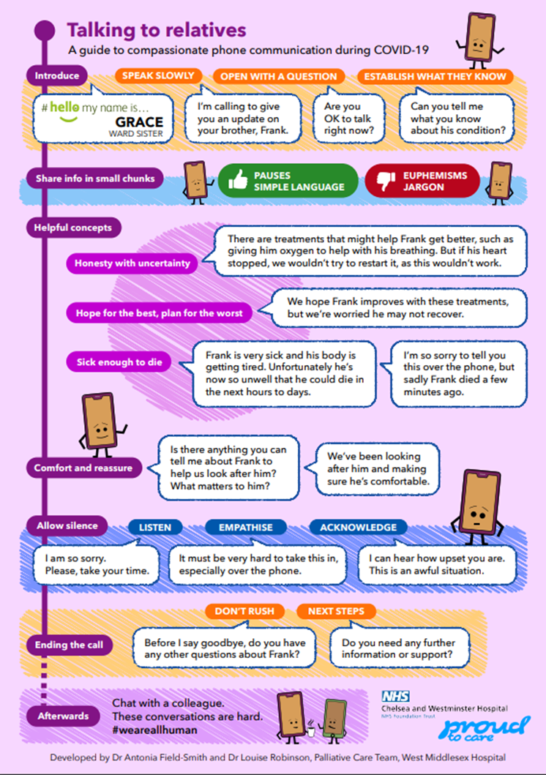

Withdrawal of NIV in patients with COVID-19

Should be managed with Specialist Palliative care team in daytime hours
NIV may be withdrawn when;
- The MDT considers it is no longer effective or
- the patient is not tolerating it and, knowing they will die, wishes for it to be removed
For NIV dependent patients NIV withdrawal may be associated with significant increases in symptoms of breathlessness and agitation and death may follow very rapidly on NIV withdrawal. NIV withdrawal will usually be a shared process between NIV medical team, nursing staff and Specialist Palliative Care team present or advising.
Ensure the patient, NOK and nursing staff are informed about the situation and process
Offer an EOL visit to the NOK.
If on NIV - this will usually only be one person for a short visit in full PPE. They will need to self-isolate for 10 days afterwards with their household. The NOK needs to be informed of the risk they place themselves in and offered a video call as an alternative if available.
If NOK visit is after NIV withdrawal and with patient in non-NIV area, may be able to support more than one visitor but may be distressing for NOK if symptoms not well controlled, or death follows NIV withdrawal very rapidly

Ensure patient is symptom controlled prior to NIV withdrawal by giving morphine 5-10 milligrams SC and midazolam 5-10 milligrams SC. Repeat after 20mins until patient is comfortable.
Many patients will already be on a syringe pump for symptom control but consider starting one with morphine 10-20 milligrams/24 hours and midazolam 10-20 milligrams/24 hours if they are not and death is not expected immediately after NIV withdrawal (if they are not NIV dependent).
Turn off or mute monitor if leaving on
Once comfortable start weaning pressure support or inspired oxygen in stages, waiting to assess comfort at each stage and giving further doses of midazolam and morphine if required. Once patient is comfortable and settled, turn off respiratory support and remove mask, replacing with 10-15L oxygen via non-rebreathe mask.
Continue symptom control as required. Consider further weaning oxygen to 5L/min via nasal cannulae. Review syringe pump doses based on symptom control already required.

Care after death in COVID-19
This advice is for cases where a COVID-19 is suspected or confirmed

Refer to local Infection Prevention and Control policy and procedures to maintain the safety of staff and relatives.

At the time of death
Open, honest and clear communication with colleagues and the deceased’s family

Consideration of emotional/spiritual/religious needs of the deceased & their family/significant others
/
significant other/s

A doctor or any appropriately trained professional completes verification of death process wearing required PPE and maintaining infection control measures

Medical Examiner (where in post) scrutinises case and discusses with attending doctor who completes Medical Certificate of Cause of Death (MCCD)

After death

of death for the purposes of completing the Medical Certificate of Cause of Death
Covid-19 is not a reason on its own to refer a death to a Coroner under the Coroners and Justice Act 2009
That Covid-19 is a notifiable disease under the Health Protection (Notification) Regulations 2010 does not mean referral to a coroner is required by virtue of its notifiable status.

- COVID-19 is an acceptable direct or underlying cause of death for the purposes of completing the MCCD and does not require Coroner referral
- If a healthcare worker may have contracted COVID-19 because of their occupation, their death must be referred to the Coroner
- Any GMC registered doctor can sign the MCCD provided a doctor has attended the patient in the 28 days before death and the certifying doctor can state the cause of death to the best of their knowledge and belief
- Any doctor can complete cremation form 4. Completion of the second part of the cremation form has been suspended. Doctors do not view the body prior to completing the cremation form 4

- NOK should be advised that conversations with the hospital bereavement office and registering the death will be by telephone, not in person
- Relatives of the deceased may not be permitted to visit after death. Later mortuary viewing may also not be possible, depending on local arrangements
- Property should be handled as per the local policy; clothing, blankets, etc should ideally be disposed of. If they must be returned to families, they should be double bagged, tied and families informed of the risks

Organ / tissue donation is highly unlikely to be an option in COVID-19

Specific guidance is available for safe religious and cultural practices after death, for example from the National Burial Council umbrella group of Muslim funeral organisations

A pacemaker or implanted cardiac defibrillator can be removed after death if there is appropriate and safe local capacity to facilitate removal. If such facilities are not available, the deceased may need to be buried not cremated. Defibrillators should be deactivated prior to death if possible.

References

National Burial Council Guidance for handling the body following death from COVID-19 Muslim deaths https://503e540b-074c-4a09-9f27-2ac007e41539.filesusr.com/ugd/9f838b_c42e8154227a45aeb721084a6d1002fa.pdf [Accessed 15 January 2021]
NHS Publications. Coronavirus Act – excess death provisions: information and guidance for medical practitioners 2020 https://www.england.nhs.uk/wp-content/uploads/2020/08/COVID-19_Act_excess_death_provisions_info_and_guidance_31_March_.pdf [Accessed 15 January 2021]

Royal College of Physicians. Talking about dying: How to begin honest Conversations about what lies ahead. RCP, London. 2018. https://www.rcplondon.ac.uk/projects/outputs/talking-about-dying-how-begin-honest-conversations-about-what-lies-ahead [Accessed 15 January 2021]

Ting R, Edmonds P, Higginson IJ, Sleeman K. Palliative care for patients with severe covid-19 BMJ 2020; 370:m2710 https://www.bmj.com/content/370/bmj.m2710 [Accessed 15 January 2021]

One page symptom guidance
Breathlessness – mild to moderate
Opioids reduce the feeling of breathlessness and can be helpful alongside active management
- Morphine modified release 5 milligrams PO bd (titrate up to maximum 30 milligrams daily according to need)
- Morphine 1.25 -2.5 milligrams PO or SC prn 4º
- Lorazepam 0.5 milligrams SL prn 6º or midazolam 1.25 -2.5 milligrams SC prn 4º for associated agitation or distress
In the last days of life
    - Morphine 2.5-5 milligrams SC prn 1º and/or midazolam 2.5 milligrams SC prn 1º
    - Consider morphine 10 milligrams and/or midazolam 10 milligrams over 24 hours via continuous SC infusion, increasing to morphine 30 milligrams / midazolam 60 milligrams step-wise as required (advice from palliative care recommended)

Breathlessness – severe

- Morphine 2.5-5 milligrams SC prn 1º (oxycodone 2.5-5 milligrams SC prn 2º or alfentanil 100-200 micrograms SC 1⁰ if low eGFR)
- Midazolam 2.5-5 milligrams SC prn 1º
- consider morphine 5-10 milligrams and / or midazolam 5-10 milligrams over 24 hours via continuous SC infusion
- Syringe pump dosing may need to be reviewed more frequently than every 24 hours if the patient’s prn requirements are escalating rapidly without control of their symptoms
- Dosing requirements may not ‘fit’ with established practice and may have to be determined on a case by case basis – always prescribe safely, but also in line with your patients’ requirements

Agitation in the last days of life

Midazolam 2.5-5 milligrams SC prn 1º
- if necessary, increase progressively to 10 milligrams SC prn 1º
- maintain with 10-60 milligrams / 24h via continuous SC infusion (start low and titrate according to need) or

Levomepromazine 25 milligrams SC prn 1º (12.5 milligrams in frail or elderly); titrate according to response
- maintain with 50-200 milligrams / 24h CSCI (start low and titrate according to need)

Seek support from your hospital Palliative Care Team

Respiratory secretions
Depending on local policy, either:
- glycopyrronium 200-400 micrograms SC prn 1º & Syringe pump with continuous SC infusion 600-1200 micrograms over 24 hours
- or hyoscine butylbromide 20 milligrams SC prn 6º & Syringe pump with continuous SC infusion 20-120 milligrams over 24 hours
- or hyoscine hydrobromide 400 micrograms SC prn 6º & Syringe pump with continuous SC infusion 1200-1600 micrograms over 24 hours

